Elevator 2021

Project is three parts:

* A simulation manager, with actors
* A specific set of actors for elevator simulation
* A visualization module, in charge of all visual interaction, either basic text mode, or sophisticated graphical UI with I/O

Simulation manager (SimMan)

* Independent from project
* Manages a swarm of actors, having state and properties
* Manages master clock representing "real time" at any rate it fits
* Some actor properties are private, other public (for visualization for instance)
* An actor should tell simulator when t_next, when next state change may occur if known
* Actors can raise an event when changing state
* Actors listening for an event can change state
* Master clock can tell actors to move to a new time t, t is guaranteed to be <= t_next

SimMan main loop:

* Foreach actor: set actor.time at SimMan.time 🡪 collection of events
* Foreach actor: process events
* t_next, a_next = min(foreach actor get next_transition_time)
* if t_next=0 then simulation ends
* set SimMan.time to t_next

For dev+test of SimMan, a circular road with traffic light and a car.

The car has a running speed, t_acceleration (time to go from 0 km/h to running speed), and t_deceleration_normal and t_deceleration_min. Car can be immobile, accelerating, running or braking.

Road has a length, it's just a parameter of the simulation, no state

Traffic light has a green duration, an orange duration and a red duration. State is green, orange or red.

Traffic light knows when next color change will occur, it's deterministic: last time state changed+state duration.

Car has to make a decision t_deceleration before traffic light

https://ville30.org/le-concept-de-ville-30/30-kmh-et-temps-de-parcours/

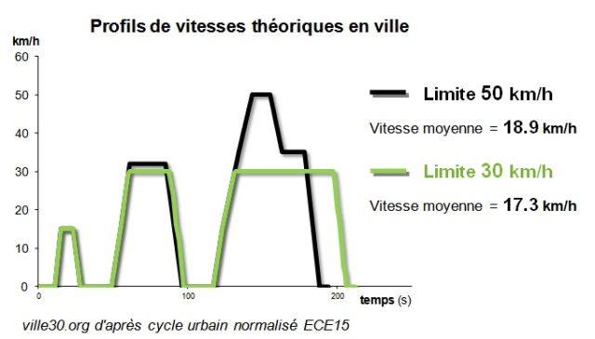

10s to go from 0 to 30 km/h, linear speed, so v = a * t

a = v/t = 30_km/h ÷ (10_s ÷ 3600_s/h) = 10 800 km.h⁻² = 0.833 m.s⁻²

30_km/h = 30000_m / 3600_s = 8.33 m/s. a = 8.33 m/s ÷ 10_s = 0.833 m.s⁻²

t_orange = 3_s (urbain) à 5s (extra-urbain)

Si la vitesse est de 30_km/h = 8.33_m/s, en 3_s on parcourt 25m

Décélération en 3s sur 25m = passer de 8.33_m/s à 0 en 3s. a = v/t = 8.33/3 = 2.78 m.s⁻²

Pour simplifier, décélération "normale" pour ne pas user les plaquettes = 1_m.s⁻2, décélération max 3_m.s⁻2.